AGRIVISION: A DRONE-BASED SYSTEM FOR DETECTING BANANA

DISEASES AND MAPPING DISEASE DISTRIBUTION USING YOLOV8,
HEATMAPS, AND GEOTAGGING



LEGACY COLLEGE OF COMPOSTELA
Dagohoy Street, Poblacion, Compostela, Davao de Oro

Institute of Information Technology

A Proposed Project Title Submitted by:

Cleentson Dewey A. Lenterna
Frincis Jane P. Omadley
Jenny Rose R. Zabala
Jase Karl M. Zerrudo

March 2026

CHAPTER I
INTRODUCTION
Background of the Study

Banana (Musa spp.) is among the most widely consumed and exported fruit crops in the world and remains an important source of food and rural income in tropical producing regions [1]. It is commonly ranked among the leading staple crops after rice, wheat, and maize, and it supplies a substantial share of dietary energy in several developing countries [2]. Despite that importance, commercial plantations are highly susceptible to Panama disease (Fusarium wilt), Black Sigatoka, and Banana Bunchy Top Virus (BBTV). These diseases reduce yield and fruit quality, and they can spread rapidly when infected mats are not identified in time [1], [2], [3], [4].
Routine detection still depends largely on visual inspection by farmers and agricultural technicians. That practice can be workable on small plots, but it is slow, labor-intensive, and open to observer bias, particularly across large plantation blocks [2], [5]. Late or inconsistent identification allows infection to continue spreading before any control measure is applied.
Computer vision has been examined as a more repeatable alternative to unaided field scouting. Segmentation and classification pipelines have been used to isolate symptomatic banana leaf regions and to assign disease labels from photographs [6]. Comparisons of convolutional architectures on banana leaf images also indicate that deep learning can outperform conventional machine-learning classifiers when the training set is adequately prepared [7].
Object-detection models in the You Only Look Once (YOLO) family have been applied directly to banana leaf conditions, including Black Sigatoka and Panama disease. Alanazi [8] reported 88.85% mAP@0.5 with YOLOv10 on 938 images spanning five leaf classes. UAV imagery has likewise been used with YOLOv8 segmentation to localize Moko and Black Sigatoka symptoms in Ecuadorian banana plantations, reaching 84.9% mAP@0.5 [9]. Reviews of aerial remote sensing show that unmanned aerial vehicles can support crop assessment over larger areas than ground photography alone [10].
Applied systems already bring these methods closer to farm use. SaBaTech, a Philippine web application, uses TensorFlow and Keras with an ESP32-CAM to identify banana pests and diseases and to issue alerts, with a reported functional suitability score of 3.72 out of 4.0 [11]. A systematic review of banana pest and disease detection identified 22 relevant studies spanning image classification, machine learning, deep learning, and mobile applications, while also noting the limited size of field-ready banana datasets [12]. Simplified training tools such as Google Teachable Machine have been shown to classify banana leaf diseases in an accessible workflow [13].
Philippine studies point in the same direction. An Android classifier based on MobileNetV2 reported 91.07% average accuracy for Lakatan leaf diseases in Davao del Sur and included mapping and infestation-rate visualization [14]. Lightweight networks compared on Black Sigatoka, Fusarium wilt race 1, and healthy leaves reached 97.12% accuracy with SqueezeNet, indicating that compact models can still perform well on banana leaf images [15].
Even so, many published banana systems still operate on close-range photographs rather than plantation-scale aerial coverage [12]. Spatial reporting is also uneven. GeoDLS geolocates diseased regions in corn fields from RTK-enabled UAS imagery [16], and UAV deep-learning pipelines have detected banana disease symptoms from high-resolution aerial RGB imagery in mixed tropical landscapes [17]. Fewer of the reviewed systems combine multi-class banana detection with geotagged locations and heatmap visualization on a plantation map interface.
AGRIVISION addresses that gap as a drone-based monitoring system for banana plantations in Compostela, Davao de Oro. Aerial images are captured at a flight altitude of 13 meters to 18 meters and a speed of 2 to 3 km/h, processed for YOLOv8 detection of Panama disease, Black Sigatoka, and BBTV, and displayed as heatmaps and geotagged locations on a leaf map interface. The intended contribution is faster surveillance and a clearer spatial picture of disease distribution than manual scouting can provide at plantation scale.

Objectives of the Study

General Objective
Develop a drone-based crop monitoring system capable of detecting banana diseases and visualizing disease distribution using YOLOv8, heatmaps, and geotagging.

Specific Objectives
- Acquire aerial images of selected banana plantations in Compostela using a drone at a predefined flight altitude of 13 meters to 18 meters and a speed of 2 to 3 km/h to provide the raw image dataset required for disease detection.
- Preprocess and enhance captured aerial images through normalization and denoising, then partition the dataset into an 80:10:10 ratio for training, validation, and testing to ensure image quality sufficient for YOLOv8 model training.
- Train a YOLOv8 model for the detection of the three primary banana diseases: Panama disease, Black Sigatoka, and Banana Bunchy Top Virus (BBTV).
- Generate heatmaps and geo-tagged disease locations integrated into a leaf map interface to visualize disease distribution across monitored plantation areas.
- Evaluate the model's performance using a confusion matrix based on accuracy, precision, recall, and F1-score, aiming for an optimal evaluation score.

Significance of the Study
This study presents a drone-based monitoring system that combines aerial imaging, YOLOv8 object detection, heatmap visualization, and geotagging for banana disease surveillance. By returning timely and spatially referenced detections, AGRIVISION is intended to support farmers, plantation managers, and later developers working on similar monitoring tools.
Farmers. The system is designed to help farmers detect Panama disease, Black Sigatoka, and BBTV from drone imagery and to locate infected areas on a map. Earlier identification of hotspots can support more prompt field action and reduce the chance that infection continues unnoticed across adjacent mats.
Banana industry. Plantation owners and other industry stakeholders may use geotagged detections and heatmap summaries to monitor blocks more systematically. The intended operational benefit is improved awareness of where disease pressure is concentrated, which can inform scouting routes and block-level management decisions.
Future developers. Developers who extend or adapt agricultural monitoring systems may reuse the project's detection, mapping, and reporting design. Possible later extensions include additional disease classes, refined models, and broader imaging setups, provided those changes remain consistent with the limits of the trained dataset.

Scope and Limitation
This study covers the development of an AI-assisted drone-based system for monitoring banana plantations from aerial imagery. The system uses YOLOv8 for disease detection and heatmap-based geotagged visualization to map disease distribution across the surveyed plantation areas. The scope of the study includes the implementation and comparative evaluation of YOLOv8 as object-detection models, while their performance is limited to the detection capabilities, configurations, and dataset used in this study.
The detection component of the system is specifically limited to the following banana diseases:
- Panama Disease (Fusarium Wilt)
- Black Sigatoka
- Banana Bunchy Top Virus (BBTV)
The study is conducted in selected banana farms in Compostela, Davao de Oro, Philippines. Aerial images are captured using a drone flown at an altitude of 13 meters to 18 meters and a speed of 2 to 3 km/h. The collected images are used to train and evaluate the YOLOv8 detection model and to generate heatmaps and geotagged disease locations on a leaf map interface.
System performance depends on the quality of the captured images. Lighting variation, wind disturbance, and weather during flight can reduce image clarity and, in turn, detection reliability.
Detection accuracy is bounded by the dataset used to train the YOLOv8, YOLOv9t, and YOLOv9s model. The system is not designed to identify diseases outside the predefined classes of Panama disease, Black Sigatoka, and BBTV.
The system is limited to monitoring and analysis. It does not apply treatments, issue automated spray commands, or generate agronomic prescriptions.

Review of Related Literature
This section presents relevant literature and previous studies that provide the foundation for the development of the proposed study. It discusses existing research, technologies, and approaches related to the study’s key concepts, serving as a basis for identifying research gaps and supporting the methods and technologies adopted in the present study.
Banana Diseases and Their Impact on Crop Productivity
Panama disease, caused by Fusarium oxysporum f. sp. cubense, is among the most serious threats to banana production. Tropical Race 4 (TR4) is of particular concern because contaminated land is difficult and costly to rehabilitate once the pathogen is established [1]. Elinisa et al. [18] note that unmanaged Fusarium wilt and Black Sigatoka can produce production losses ranging from 30% to 100% in East African settings, which underscores why early recognition of vascular-wilt symptoms matters. Nassor et al. [15] classified Fusarium wilt race 1 against Black Sigatoka and healthy leaves using lightweight convolutional networks, showing that wilt-related foliar symptoms are computationally separable in leaf images. AGRIVISION treats Panama disease as one of three detection classes in aerial plantation imagery rather than as a laboratory diagnostic of the pathogen race.
Black Sigatoka, caused by Pseudocercospora fijiensis, produces necrotic leaf streaks that reduce photosynthetic area and fruit filling [3], [4]. Goenaga et al. [3] reported that, without cultural and chemical control, black leaf streak can reduce yields by 20% to 80% depending on severity, and that infected plants may yield fruit that ripens prematurely. Kimunye et al. [19] found yield losses exceeding 50% under some cultivar and site conditions, with environment accounting for 39.1% of observed disease-severity variation. Noar et al. [4] describe Black Sigatoka as the most important banana foliar disease in many producing regions and document long-distance spore movement. These agronomic findings justify treating Black Sigatoka as a primary aerial-detection class in AGRIVISION, because canopy lesions are visible from above and are spatially clustered once an outbreak is underway.
BBTV causes stunted growth, upright bunched leaves, and chlorotic margins, and it has become a major constraint in parts of Asia and sub-Saharan Africa [2]. Mora et al. [2] report that BBTV outbreaks have been documented in at least six countries in the past decade. Nasim et al. [12] and Erasmo and Perito [14] likewise list bunchy top among the principal banana diseases addressed by image-based classifiers. Computational detection of BBTV is less common than work on Sigatoka or Fusarium wilt in the UAV literature reviewed here. Including BBTV with Panama disease and Black Sigatoka therefore fills a practical monitoring gap for Compostela plantations, where more than one of these diseases may be present.
Method choice follows from that disease context. Krishnan et al. [6] used hybrid segmentation plus deep classification for banana leaf images, while Vidhya and Priya [7] found that several CNN backbones exceeded 90.6% test accuracy on healthy, leaf-spot, and Sigatoka classes after augmentation and an 80:10:10 split. Those results support deep learning over handcrafted feature pipelines for the present study, without implying that any single architecture is universally best.

Artificial Intelligence in Plant Disease Detection
Reviews of automated plant-disease diagnosis describe a shift from manual scouting toward image-based machine learning. Francisco et al. [20] examined 48 studies and found convolutional networks and transfer learning to be the dominant approaches, with many reported accuracies above 90%, although banana was less represented than crops such as tomato. Rodriguez-Lira et al. [21] similarly documented CNN dominance in work published from 2019 to 2024 and flagged robustness under field conditions as an open need. Pacal et al. [22] synthesized 160 papers from 2020 to 2024 across classification, detection, and segmentation, and restated FAO estimates that pests and diseases can remove 20% to 40% of global production. Yani et al. [5] reached a related conclusion for leaf-disease recognition: deep models are widely adapted, yet larger datasets, stronger field generalization, and better interpretability remain unresolved.
Banana-specific reviews and local systems make the remaining gap clearer. Nasim et al. [12] retained 22 banana studies and found that most operate on close-range leaf or fruit images rather than aerial plantation views. Philippine systems, including Erasmo and Perito [14], Ancheta et al. [13], and Gerance et al. [11], show that banana disease AI is already being built for local users, but they remain ground-based. AGRIVISION extends that local line of work by moving capture to a drone, using YOLOv8 for multi-class detection, and returning heatmap-geotagged outputs.

YOLO-Based Object Detection for Agricultural Applications
YOLO treats detection as a single-pass regression of bounding boxes and class probabilities, which is why it is widely used when inference speed matters [23]. Kamalesh Kanna et al. [23] reviewed YOLO versions in agricultural remote sensing and drone applications, including crop, pest, and disease tasks. Khan et al. [24] compared Faster R-CNN, YOLO, and SSD for agricultural object detection and noted the usual trade-off among accuracy, latency, and compute, together with persistent problems of environmental variability and limited labeled data. AGRIVISION's flight settings (18 m altitude, 2-3 km/h) are intended to keep ground sampling distance fine enough for foliar symptoms while still covering plantation blocks.
Banana studies give more direct support for that choice. Alanazi [8] obtained 91.22% precision and 85.06% recall with YOLOv10 on banana leaf images that included Panama disease and Black Sigatoka. Oviedo et al. [9] applied YOLOv8 segmentation to UAV banana imagery for Moko and Black Sigatoka and reported 84.9% mAP@0.5. Mora et al. [2] compared YOLO-NAS, YOLOv8, YOLOv9, and Faster R-CNN for georeferenced banana-wilt surveillance and found YOLOv9 strongest on aerial images (mAP@50, precision, and recall from 55% to 86%) and YOLOv8 strongest on ground images (65% to 99%, depending on plant part and region). Taken together, these results justify YOLOv8 for AGRIVISION's multi-class aerial detector, while leaving open the difficulty of small or early symptoms at altitude [23], [24].

Drone-Based Agricultural Monitoring and Geotagged Disease Mapping
UAV platforms supply on-demand, georeferenced RGB imagery at plantation scale. Teixeira et al. [10] reviewed deep learning for crop analysis from satellite and UAV imagery and described CNNs, recurrent models, and hybrid designs used for mapping and related tasks. Mora et al. [17] detected banana Xanthomonas wilt from UAV RGB and pansharpened imagery in mixed African landscapes, with YOLOv8 and Faster R-CNN F1 scores from 75% to 99%; RGB and pansharpened images outperformed lower-resolution multispectral inputs. Those findings support AGRIVISION's use of drone RGB capture rather than a close-range only workflow.
Geotagging turns detections into locations that can be revisited. Ahmad et al. [16] developed GeoDLS to identify and geolocate corn disease regions from RTK-tagged UAS tiles and to notify users of infection percentages at GPS coordinates. Mora et al. [2] extended georeferenced surveillance to banana wilt using aerial and ground platforms with human-in-the-loop refinement. AGRIVISION follows that spatial-reporting idea by writing geotagged detections and heatmaps to a leaf map interface so that Compostela growers can see where Panama disease, Black Sigatoka, and BBTV detections cluster.

Heatmap Visualization for Disease Distribution Analysis
A heatmap uses color intensity to show where detections concentrate across geographic coordinates. Instance-level UAV segmentation, as in Oviedo et al. [9], localizes symptomatic regions from the air and thereby supplies the points that a spatial overlay can aggregate. GeoDLS [16] showed that georeferenced detections can be summarized as field-level infection information. AGRIVISION combines YOLOv8 outputs with GPS metadata from drone capture to display heatmaps of the three target diseases. The map is a decision-support view, not a substitute for laboratory confirmation of the pathogen.
Banana remains a major fruit and staple crop in tropical agriculture, including in Compostela, Davao de Oro, where plantations support local livelihoods [1], [2]. Productivity continues to be constrained by Panama disease, Black Sigatoka, and BBTV, which differ in pathology but share a practical need for timely, spatially explicit monitoring [2]-[4]. AGRIVISION targets those three diseases through YOLOv8-based aerial detection and heatmap-geotagged visualization.

Review of Related System
This section presents previous studies that are closely related to the development of the proposed system. It examines their methodologies, technologies, findings, and contributions to provide a basis for comparison and identify gaps that the present study aims to address.
GeoDLS
GeoDLS, developed by Ahmad et al. [16], tracks corn disease from RTK-geolocated UAS imagery using multiple convolutional backbones, including VGG16, ResNet50, and DenseNet169. The system identifies diseased regions, attaches GPS coordinates, and reports infection percentages to users. GeoDLS demonstrates geotagged disease mapping from aerial imagery, but it targets corn rather than banana, does not use YOLOv8, and does not present heatmap overlays on a banana plantation leaf map. AGRIVISION adapts the geolocation idea to banana monitoring with YOLOv8 and heatmap integration.
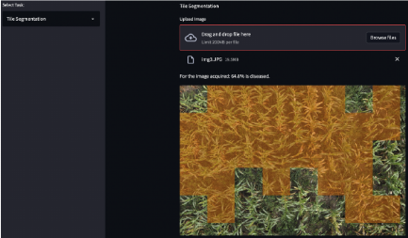
Figure 1. Sample Image for GeoDLS: A Deep Learning-Based Corn Disease Tracking and Location System Using RTK Geolocated UAS Imagery

SabaTech
SaBaTech, developed by Gerance et al. [11], is a Philippine web application for banana pest and disease detection. It uses TensorFlow/Keras for classification and an ESP32-CAM for real-time capture, and it provides SMS alerts, data visualization, and report generation. ISO/IEC 25010 evaluation gave functional suitability the highest mean score at 3.72 out of 4.0. SaBaTech operates on close-range fruit and leaf images and does not include drone capture, heatmap visualization, or geotagged plantation mapping. AGRIVISION is directed at those missing pieces through aerial imaging and spatial display.
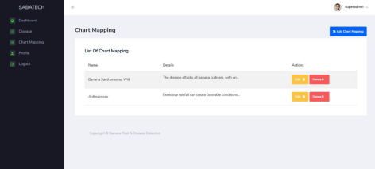
Figure 2. Sample Image for SaBaTech: A Banana Fruit Pest and Disease Detection Web Application

UAV-plus-YOLO pipelines have also been validated on rice, which is useful as an architectural precedent even though the crop differs. Masykur et al. [25] evaluated YOLOv4 on rice images captured by drone at 2, 5, 10, and 20 meters and reported precision of 46.8%, 48%, 65%, and 77.3%, respectively, showing that capture distance affects detection. Pan et al. [26] modified YOLOv8 as Xoo-YOLO for wild-rice bacterial blight from UAV views and obtained 94.95% mAP. These studies support the combination of drone imagery and YOLO, while leaving banana disease classes, Compostela field conditions, and heatmap-geotagged leaf-map output as AGRIVISION's distinct integration.
The closest banana aerial systems in the reviewed set are Oviedo et al. [9], who detected Moko and Black Sigatoka from UAV imagery with YOLOv8 segmentation, and Mora et al. [2], who performed georeferenced banana-wilt surveillance across aerial and ground platforms. Relative to those systems, AGRIVISION is designed around three locally prioritized classes (Panama disease, Black Sigatoka, and BBTV), heatmap visualization, geotagged points on a leaf map interface, and deployment in Compostela, Davao de Oro.

Table 1. Comparison of Related Systems
List of Function | SaBaTech | GeoDLS | AGRIVISION
Target crop | Banana | Corn | Banana
Primary purpose | Ground-based pest and disease identification | Geolocated corn disease tracking | Aerial banana disease detection and mapping
Image source | ESP32-CAM (ground-level) | RTK geolocated UAS imagery | Drone aerial images (18 m altitude, 2-3 km/h)
Detection algorithm | TensorFlow/Keras CNN | VGG16, ResNet50, DenseNet169, etc. | YOLOv8
Disease classes covered | General banana pests and diseases | Corn leaf diseases (NLB, GLS, rust) | Panama disease, Black Sigatoka, BBTV
Aerial/drone monitoring | No | Yes | Yes
Geotagged disease locations | No | Yes | Yes
Heatmap visualization | No | No | Yes
Leaf map interface | No | No | Yes
Web-based system | Yes | Yes (notification system) | Yes
Confusion matrix evaluation | Not reported | Not reported | Yes
Table 1 compares SaBaTech and GeoDLS with AGRIVISION in order to show which monitoring functions are present or absent in each system.

Synthesis
The literature supports four linked points. First, Panama disease [1], [15], [18], Black Sigatoka [3], [4], [19], and BBTV [2], [12], [14] remain economically important banana constraints. Second, systematic reviews find deep learning, especially CNNs and YOLO-style detectors, more suitable than unaided visual inspection for image-based diagnosis [5], [20]-[24]. Third, banana AI in the Philippines is active but still largely ground-based [11]-[14], while UAV YOLO systems for banana [2], [9], [17] and rice [25], [26] show that aerial detection is feasible. Fourth, geotagged aerial mapping exists for corn [16] and for banana wilt surveillance [2], yet heatmap-geotagged visualization of Panama disease, Black Sigatoka, and BBTV together is not the standard output of the systems reviewed.
AGRIVISION brings those strands into one workflow: drone capture at 18 meters and 2-3 km/h, preprocessing with an 80:10:10 train-validation-test split, YOLOv8 detection of the three target diseases, heatmap and geotagged display on a leaf map interface, and evaluation through confusion-matrix metrics (accuracy, precision, recall, and F1-score). The system is offered as a decision-support tool for farmers in Compostela, Davao de Oro, not as a replacement for expert diagnosis or laboratory confirmation.

Definition of Terms
Aerial Image. | A photograph captured from an elevated position using an unmanned aerial vehicle (drone), used as the primary input for disease detection and spatial mapping in this study [10].
Banana Bunchy Top Virus (BBTV). | A viral disease of banana plants transmitted by aphids, characterized by stunted growth, narrow upright leaves, and chlorotic or bunched foliage, and identified as a major constraint in parts of Asia and sub-Saharan Africa [2].
Black Sigatoka. | A foliar fungal disease caused by Pseudocercospora fijiensis, producing dark leaf streaks and necrotic lesions that reduce photosynthetic capacity and fruit quality [3], [4].
Confusion Matrix. | A tabular evaluation layout that compares predicted disease labels against actual labels, from which accuracy, precision, recall, and F1-score are derived in this study.
Drone (UAV). | An unmanned aerial vehicle equipped with a camera and used to capture georeferenced images of banana plantations from a predefined flight altitude and speed [10], [17].
F1-Score. | The harmonic mean of precision and recall, used in this study as a single summary of false positives and false negatives during YOLOv8 evaluation.
Heatmap. | A spatial visualization that uses color intensity to represent the concentration of detected disease occurrences across a mapped plantation area, built from georeferenced detection outputs [9], [16].
Panama Disease (Fusarium Wilt). | A soil-borne fungal disease caused by Fusarium oxysporum f. sp. cubense that blocks vascular tissue, causing leaf yellowing, wilting, and plant death [1].
Precision. | The proportion of true positive detections among all positive predictions made by the model, used here to describe the reliability of YOLOv8 identifications.
Recall. | The proportion of actual disease instances correctly detected by the model, used here to describe how completely YOLOv8 identifies the target classes.
YOLOv8 (You Only Look Once version 8). | A single-stage deep learning object detector used in this study to identify Panama disease, Black Sigatoka, and BBTV from aerial banana plantation images [9], [23].

CHAPTER 2
METHODOLOGY
This chapter presents the methods used to develop AGRIVISION: A Drone-Based System for Detecting Banana Diseases and Mapping Disease Distribution Using YOLOv8, Heatmaps, and Geotagging. The proponents adopted Agile software development, an iterative approach that emphasizes repeated planning, collaboration, testing, and adjustment as requirements become clearer.
Agile development allowed each feature to be designed, implemented, tested, and revised on the basis of ongoing evaluation. The intent was to keep the software aligned with the stated objectives while remaining able to correct defects discovered during later sprints.
Development followed the phases of the System Development Life Cycle inside that Agile frame: System Planning, System Analysis, System Design, System Development and Implementation, System Testing, and System Maintenance. Each phase contributed to building, checking, and later maintaining the system. Figure 3 shows the Agile process adopted for AGRIVISION.
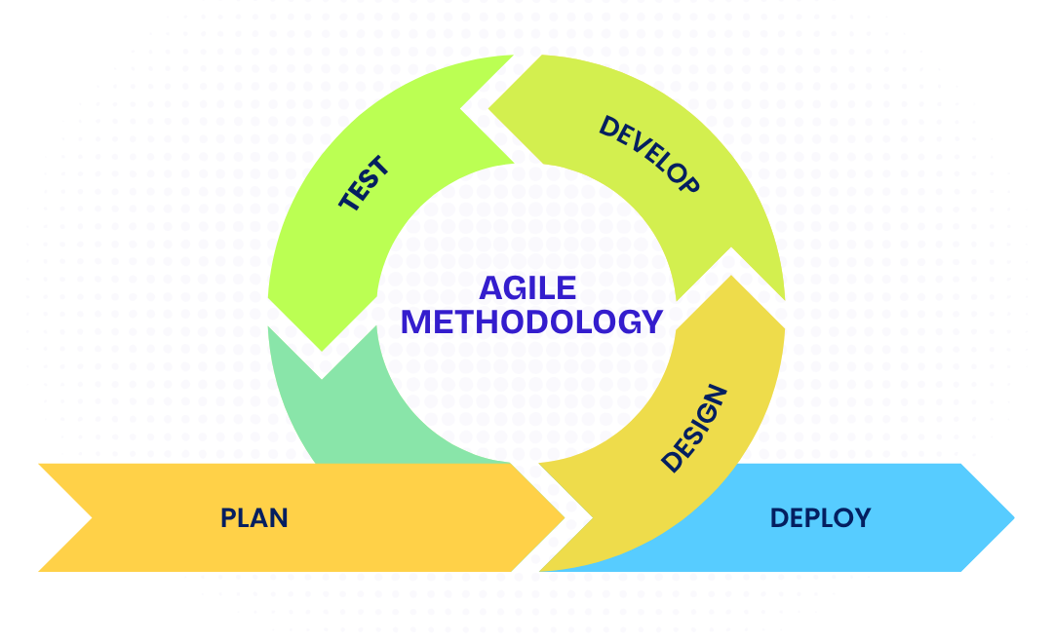
Figure 3. Agile Software Development Methodology
System Planning
System planning set the managerial and technical baseline. The proponents defined scope, schedule, roles, and resources against the capstone calendar from March 2026 to September 2026. Planning work included stakeholder identification, risk assessment, proposal preparation, and schedule baselining.

Project Team Organization
Each member of the project development team has an individual role and function that contributes to AGRIVISION. Figure 4 shows the project team organization and the designated responsibilities of each member.
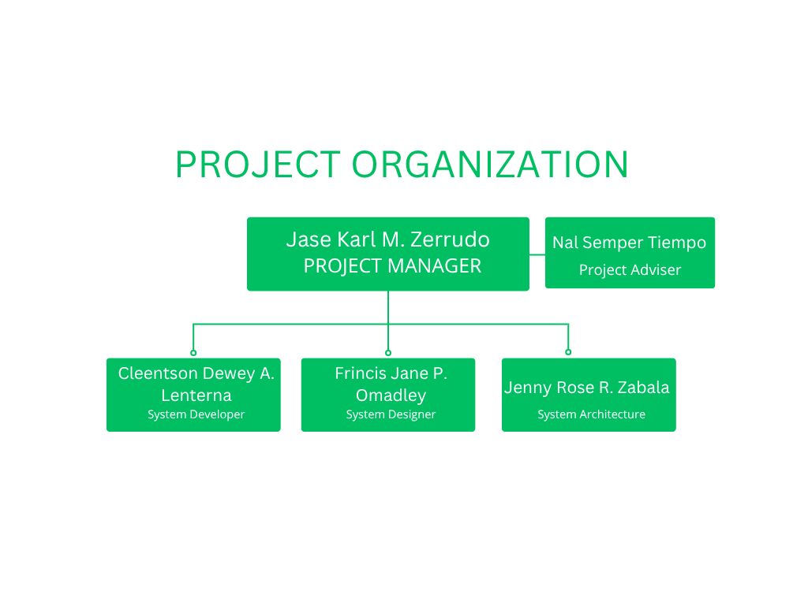
Figure 4. Chart of the Project Development Team
Accountability is headed by the Project Adviser, Nal Semper Tiempo, who provides methodological direction, quality oversight, and formal validation of major deliverables. The Project Manager, Jase Karl M. Zerrudo, coordinates schedule execution, risk tracking, stakeholder communication, and milestone acceptance. The System Architect, Jenny Rose R. Zabala, defines the layered architecture, API contracts, and data-flow constraints. The System Designer, Frincis Jane P. Omadley, produces interface specifications, dashboard layouts, and visualization standards. The System Developer, Cleentson Dewey A. Lenterna, implements the backend, model integration, preprocessing routines, and map-related features using Python, YOLOv8, and web technologies.

Work Breakdown Structure (WBS)
This section presents the work breakdown structure used by the proponents. A work breakdown structure organizes deliverables and tasks into manageable units. Figure 5 shows AGRIVISION divided into twelve phases.
The work breakdown structure (WBS) decomposes AGRIVISION into measurable work packages. Critical paths include dataset readiness before full model training, model stabilization before system integration, and integration completion before field testing.
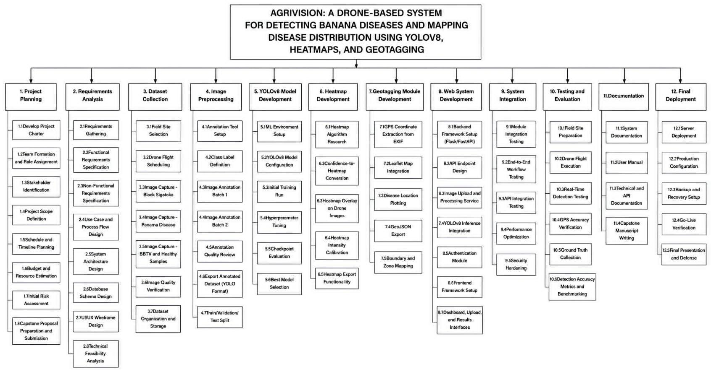
Figure 5. Work Breakdown Structure of AGRIVISION

Gantt Chart
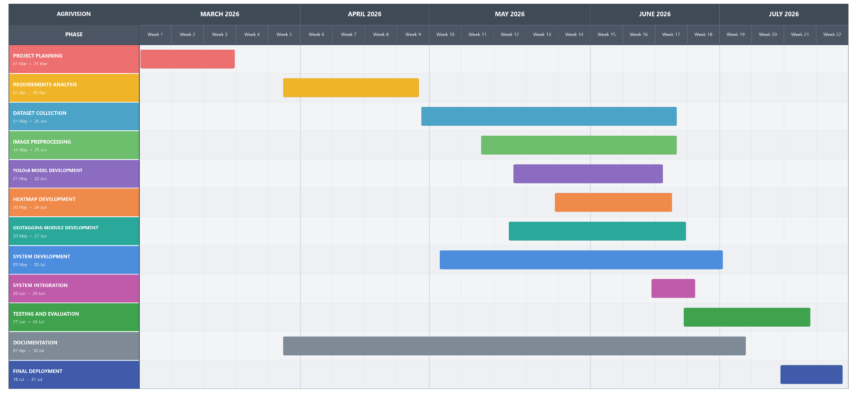
This section presents the project schedule for AGRIVISION, aligned with the Work Breakdown Structure. The Gantt chart covers planning through development, testing, deployment, and maintenance. Figure 6 shows the master schedule with phase-based color coding and task bars for sequence, duration, and dependencies. Progress is monitored through weekly stand-ups and variance checks against baseline dates.
Figure 6. Gantt Chart of AGRIVISION
System Analysis
After planning, the proponents gathered the information needed to specify what AGRIVISION must do and how data move among actors, modules, and stores. System analysis recorded user expectations, operational constraints, and processing requirements for drone imagery, disease detection, and geospatial visualization.

System Architecture

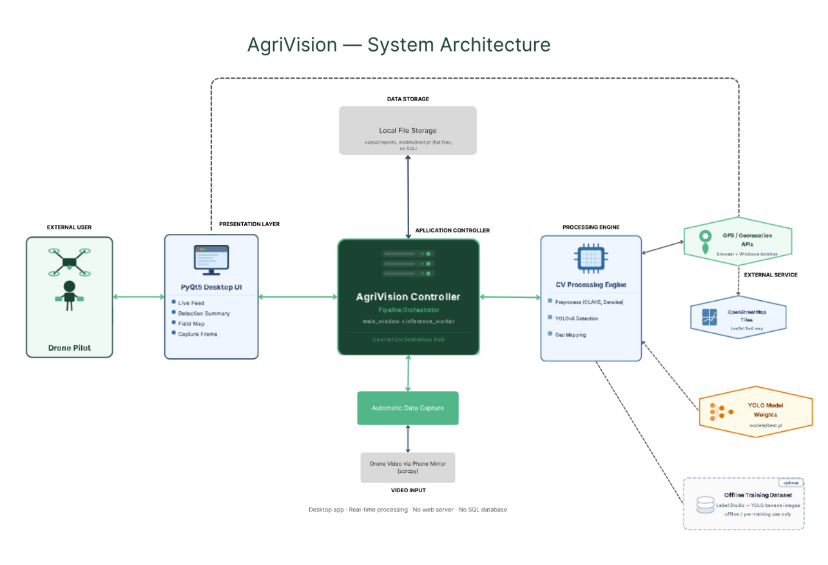
Figure 7. System Architecture of AGRIVISION
The study uses a developmental and applied design: AGRIVISION is built and then evaluated as a drone-based banana disease detection and mapping system. It combines computer vision, deep learning, geospatial mapping, and UAV image capture. Design and evaluation used simulated data and controlled image datasets chosen to represent banana plantation conditions.
Two related models describe the work: Figure 8. (a) the Input-Process-Output (IPO) model, which summarizes data flow at a high level; and (b) the AGRIVISION simulation framework, which states the operational pipeline step by step.
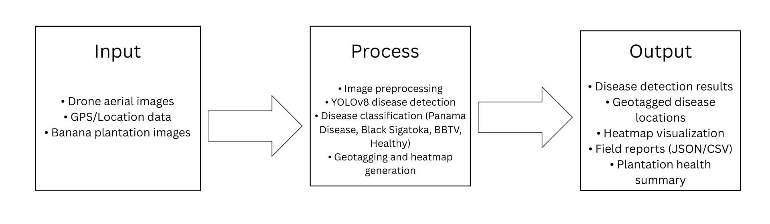

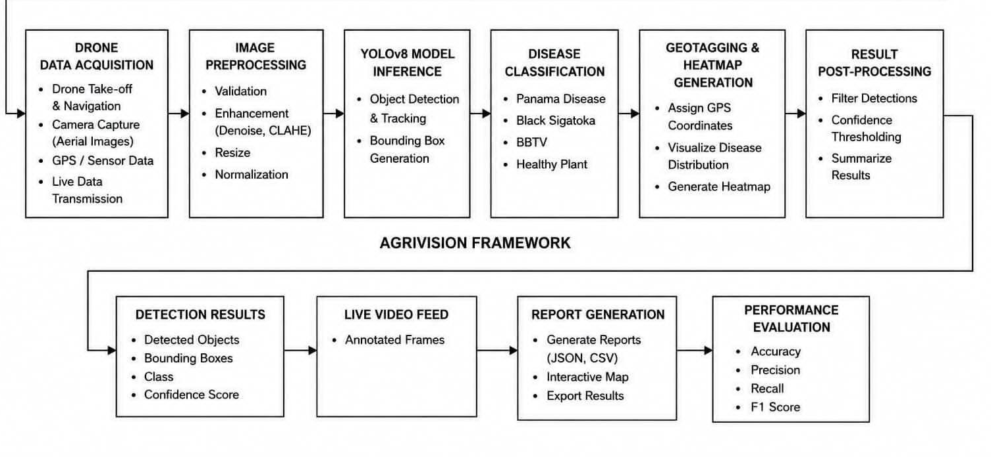
(a)Input Process Output
- AGRIVISION Simulation Framework
Figure 8. Conceptual Framework of AGRIVISION

Functional and Non-Functional Requirements
The functional and non-functional requirements below state what the system must do and the quality attributes expected by users.
Functional Requirements
- The system must identify the target banana diseases from aerial input images captured through a wireless drone feed or a phone mirror feed.
- The system must classify healthy and diseased banana plants (Black Sigatoka, Bunchy Top, Panama disease, and healthy) and report detection performance using validation metrics such as precision, recall, and mAP.
- The system must provide geotagged disease information, field health summaries, and exported reports (JSON, CSV, and interactive map) for monitoring plantation conditions.
- The system must preprocess captured images locally and support disease detection and visualization using the trained models and available datasets without requiring an internet connection..
Non-functional Requirements
- The system must remain usable for the pilot user with limited technical training through a single desktop dashboard that provides a live feed, detection overlays, and one-click field-report export.
- The system must operate offline for live capture, inference, and report export, with optional online connectivity for map basemap tiles and GPS auto-detection.
- The system must run on Windows desktop computers and support Android devices as a wireless mirror source for aerial video capture via scrcpy.
- The system must be reliable and maintainable, with automated smoke testing, a modular pipeline, and a low risk of session-stopping errors during field use.
Use Case Diagram
A use case diagram shows the interactions between the user and the system. As shown in Figure 9, the Drone Pilot is the primary actor. The pilot connects the drone's live video feed through screen mirroring, starts and stops live detection, monitors results on the video feed, summary, and map, sets the plantation GPS location, and captures and exports monitoring reports. These interactions cover real-time crop monitoring, geospatial mapping, and report generation.
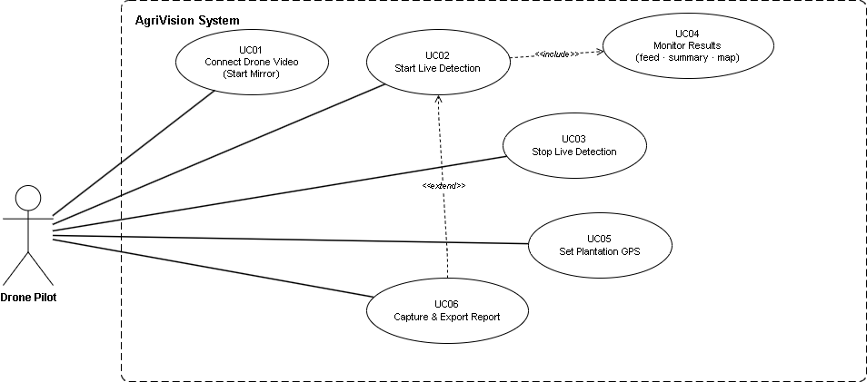
Figure 9. Use Case Diagram of AGRIVISION

Context Flow Diagram (Level 0)
The Context Flow Diagram (Level 0) gives an overview of exchanges between the external entity and AGRIVISION. As shown in Figure 10, the Pilot provides the casted drone screen feed. The system uses the YOLOv8 model and heatmap generation to analyze the incoming video and return visual detection results to the Pilot. Processed detection data are also stored in the Dataset for later reference, analysis, and possible model improvement.
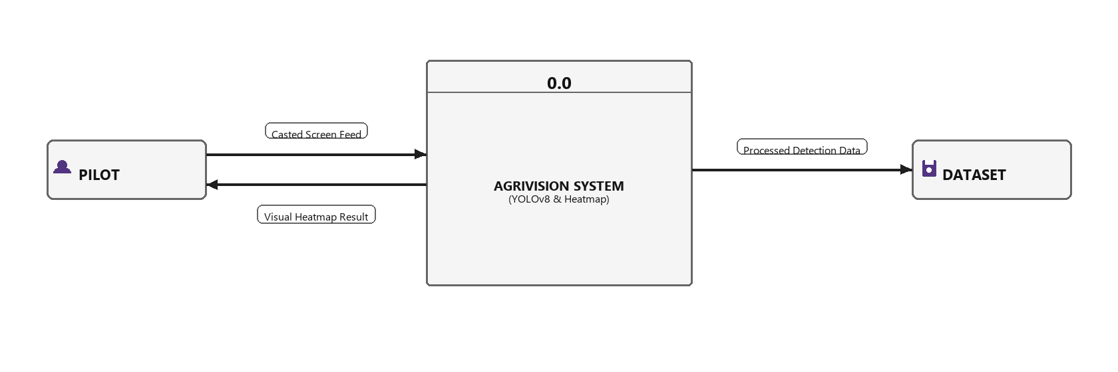
Figure 10. Context Flow Diagram of AGRIVISION

Level 1 Data Flow Diagram
The Level 1 Data Flow Diagram expands the context diagram into internal processes. As shown in Figure 11, the Pilot sends the casted screen to the Screen Cast module. Frames go to the YOLOv8 model for detection. Processed records are stored in the Dataset, and detection coordinates go to Generate Heatmap, which produces heatmaps and overlays for the Pilot. The diagram shows how data move from capture to detection and visualization.
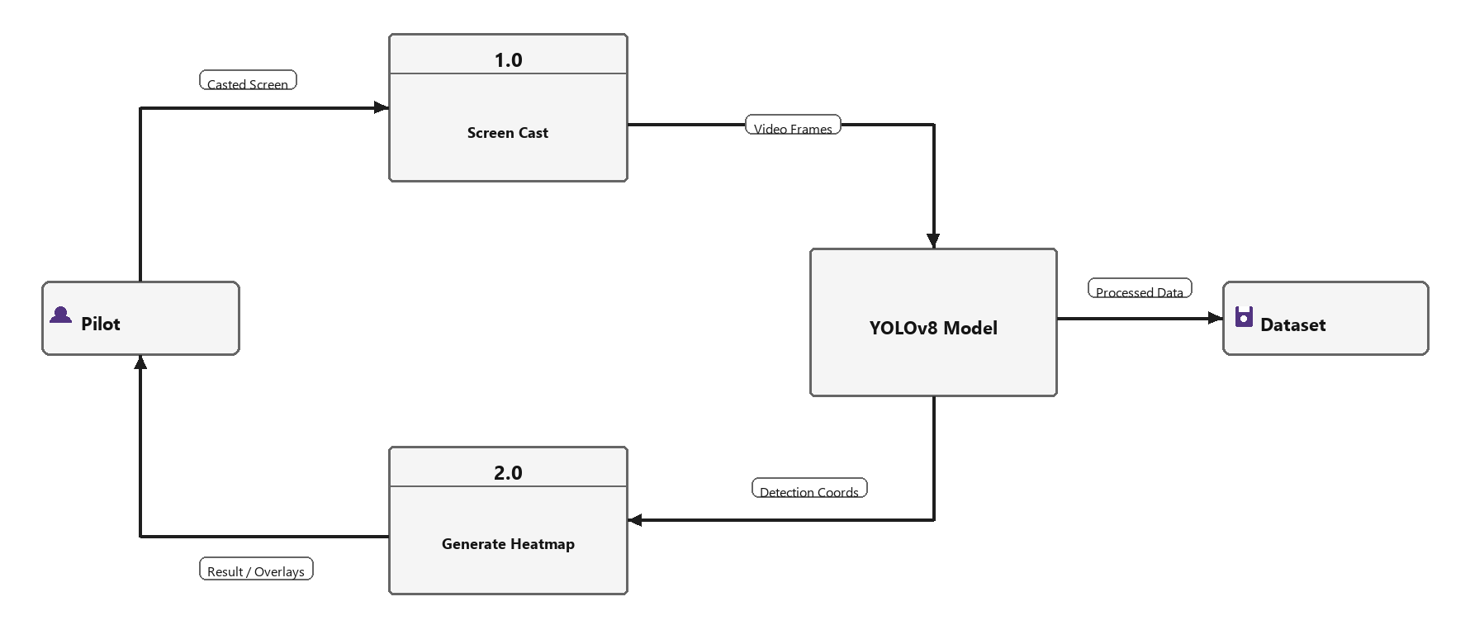
Figure 11. Level 1 Data Flow Diagram of AGRIVISION

System Design
This section presents the planned system designs and the technologies, concepts, and theories used in the study.

JSON Schema Diagram
The entity-relationship view in Figure 12 organizes AGRIVISION data objects. The live drone feed from VideoSource is processed into Frame objects, producing AnalysisResult records linked with GeoTag and GeoMarker information for the LiveMap. Captured data are compiled into a FieldReport, and the corresponding images, reports, and map files are stored as Artifacts.
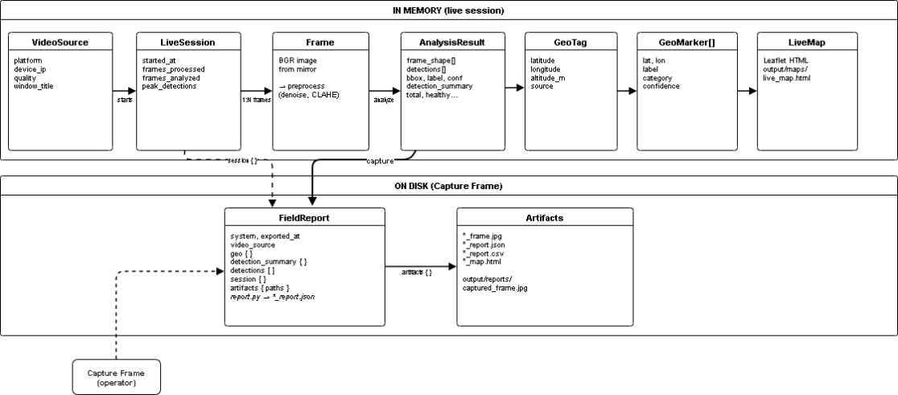
Figure 12. Entity Relationship Diagram of AGRIVISION

Data Dictionary
The data dictionary lists the data elements used in the system. Tables 3 through 11 describe the logical entities of AGRIVISION.

Table 2 . LiveSession (in-memory)
Field | Type | Description
session_id | string | 4-hex folder id
video_id/ flight-id | string | pre-flight AGV-...id
started_at | string (ISO-8601 UTC) | Session start timestamp
frames_processed | integer | Total frames pulled from mirror
frames_analyzed | integer | Frames that completed inference
total_detections | integer | Cumulative detection count
peak_detections | integer | Max detections in a single analyzed frame
last_detection_summary | object | {total, healthy, stressed, diseased}
manual-tags | ManualTag[] | Operator map pins
geo_marker_count | integer | Count of markers on current map
last_geo | object | Last GeoTag used for mapping
detector | {id, name, weights} | Live model (yolov9s default

Table 2 shows a session object built around identifiers and a start time, two paired integer counters for frames and detections, nested health and vegetation summaries, operator and plantation tags, and an explicit live-model record. It does not report empirical results; those would have to come from populated LiveSession instances, not from this schema.

Table 3. Detection (per bounding box)
Field | Type | Description
bbox | array[4] integer | [x1, y1, x2, y2] pixels, top-left origin
label | string | Display label, e.g. Healthy (0.92)
confidence | float | Model confidence 0.0–1.0
class | integer | YOLO class id (see data.yaml)

Table 3 defines a Detection as one bounding box. The box is a four-integer array [x1, y1, x2, y2] in pixels with a top-left origin. The remaining fields are a display label (illustrated as Healthy (0.92)), a confidence float bounded from 0.0 to 1.0, and an integer YOLO class id resolved in data.yaml. The table therefore separates geometry, human-readable text, model score, and class index.

Table 4. HealthSummary (aggregated per frame)
Field | Type | Description
total | integer | Count of valid detections
healthy | integer | Healthy category count
stressed | integer | Stressed / moderate count
diseased | integer | Diseased count

Table 4 aggregates those detections per frame into a HealthSummary of four integers: total (valid detections), healthy, stressed (also described as moderate), and diseased. The structure matches the {total, healthy, stressed, diseased} object already referenced from LiveSession. The table does not assign sample counts; it only defines the four counters.

Table 5. GeoTag (plantation anchor)
Field | Type | Description
latitude | float | Decimal degrees (WGS84)
longitude | float | Decimal degrees (WGS84)
altitude_m | float | null | Altitude in meters (optional)
source | string | manual, browser_gps, windows_gps, default, env

Table 5 defines GeoTag as the plantation-level location record. It comprises four fields: latitude and longitude as floats in decimal degrees on WGS84, altitude_m as an optional float that may also be null, and source as a string that records how the coordinates were obtained.

Table 6. GeoMarker (map pin per detection)
Field | Type | Description
lat | float | Marker latitude
lon | float | Marker longitude
label | string | Detection label
category | string | healthy | stressed | diseased
confidence | float | Detection confidence

Table 6 defines GeoMarker as one map pin attached to a single detection, not to the plantation as a whole. It comprises five fields: lat and lon as floats, label as a string for the detection label, category as a string limited to healthy, stressed, or diseased, and confidence as a float for the detection score.

Table 7. FieldReport (export root JSON)
Field | Type | Description
system | string | Always "AgriVision"
exported_at | string (datetime) | Capture timestamp (local ISO)
video_source | string | e.g. scrcpy, android
geo | object | GeoTag fields
detection_summary | object | HealthSummary
detections | array | List of Detection
session | object | LiveSession snapshot
artifacts | object | Paths to frame, JSON, map files

Table 7 defines FieldReport as the export-root JSON. It always sets system to AgriVision, records exported_at as a local ISO datetime string, and names the video_source (examples: scrcpy, android). Nested objects reuse earlier entities: geo (GeoTag), detection_summary (HealthSummary), detections (array of Detection), and session (a LiveSession snapshot). artifacts stores paths to frame, JSON, and map files. The report is therefore a single package of identity, location, summary counts, box-level detections, session state, and file paths.

Table 8. FieldReport CSV columns (summary and geo rows)
section | field | value (example)
summary | total | 12
summary | healthy | 8
summary | stressed | 2
summary | diseased | 2
geo | latitude | 7.3669
geo | longitude | 125.91
geo | altitude_m | (empty)
geo | source | manual

Table 8 is the only table that reports a worked example of those summary and geo rows. Of 12 valid detections, 8 are healthy, 2 are stressed, and 2 are diseased. Healthy is the largest category; stressed and diseased are tied at the lowest count. The three category counts sum to the stated total of 12. The plantation anchor is latitude 7.3669, longitude 125.91, with altitude_m empty and source equal to manual, one of the five sources listed in Table 5, and consistent with altitude being optional.

Table 9. FieldReport CSV detection rows
label | confidence | class | bbox
Healthy (0.92) | 0.92 | 2 | 10 10 50 50

Table 9 shows one CSV detection row that follows Table 3: label Healthy (0.92), confidence 0.92, class 2, and bounding box 10 10 50 50. The confidence equals the value embedded in the label and lies near the top of the 0.0–1.0 range in Table 3. The box is given as four pixel integers, matching the [x1, y1, x2, y2] layout.

Table 10. YOLO training label (offline)
Field | Format | Description
class_id | integer 0–3 | Disease class index
x_center | float 0–1 | Normalized bbox center x
y_center | float 0–1 | Normalized bbox center y
width | float 0–1 | Normalized bbox width
height | float 0–1 | Normalized bbox height

Table 10 specifies the offline YOLO training label: integer class_id in 0–3, plus four floats in 0–1 for normalized box center (x_center, y_center) and size (width, height). Relative to Table 4, training labels use a normalized center-and-size box rather than pixel corner coordinates, and they use four class indices (0–3) rather than the three live categories (healthy, stressed, diseased) shown in Tables 4 and 6.

Technologies, Concepts, and Theories
The technologies, concepts, and theories applied in AGRIVISION are summarized in Table 12.
Area | Technology / theory | Logo | Role in AgriVision
Object detection | YOLOv8 (Ultralytics) |  | Bounding-box disease / plant detection on aerial frames
Deep learning runtime | PyTorch | 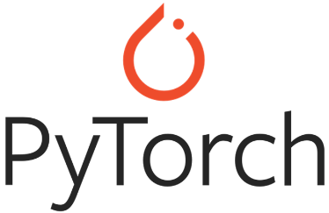 | Model inference and fine-tuning (models/best.pt)
Computer vision | OpenCV |  | Preprocess, draw overlays, image I/O
Preprocessing | Bilateral denoise, CLAHE (LAB), ECC temporal alignment |  | Improve contrast and stability before inference
Vegetation index (proxy) | ExG / HSV green-band ratio |  | Frame quality gate (utils/frame_quality.py)
Geo mapping | Local tangent-plane offset (meters → lat/lon) | 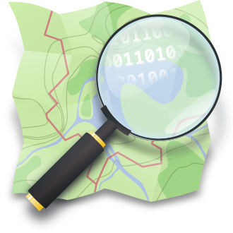 | Map detection centers to field coordinates
Map visualization | Leaflet + OpenStreetMap tiles |  | Interactive field map in UI and HTML export
Desktop UI | PyQt5 |  | Operator dashboard (feed, sidebar, controls)
Video capture | scrcpy (Android mirror) |  | Primary aerial video source from phone/drone app
Annotation pipeline | Label Studio → YOLO export |  | Offline training dataset preparation
Software architecture | Pipeline pattern, background worker thread |  | backend/pipeline.py, ui/inference_worker.py
API/ UI | FastAPI, React, Vite, Recharts |  | KPIs, records, model comparison
Security | HMAC-SHA256 bearer tokens |  | Single-admin access contro
Spatial | Haversine radius clustering |  | Disease-affected zone circles
Persistence | JSON / CSV AJPG HTML files |  | No database; desktop writes, AP reads
Method | Agile SDLC + IPO + pipeline |  | Iterative build; Input - Process - Output
Evaluation | Precision, recall, F1, mAP, AdamW |  | Confusion matrix and architecture benchmark
Table 12. Technologies Used in AGRIVISION

System Testing
This section reports the system testing and evaluation of AGRIVISION. The proponents assessed whether the implemented system met the stated functional and quality requirements. The YOLOv8n, YOLOv9t, and YOLOv9s architectures were trained and tested under the specified training configurations to evaluate their performance using accuracy, recall, precision, and F1-score. The numerical results presented in this section are those recorded during testing.

Epochs | Accuracy (mAP@0.5) | Recall | Precision | F1
20 | 11.19% | 12.16 | 87.20 | 21.34
40 | 10.25% | 9.58 | 36.46 | 15.17
60 | 14.24% | 15.75 | 44.15 | 23.22
80 | 14.60% | 19.61 | 19.89 | 19.75
100 | 14.75% | 22.56 | 17.59 | 19.76
Average | 13.00% | 15.93 | 41.06 | 19.85
Table 13. YOLOv8n Results Using AdamW Optimizer

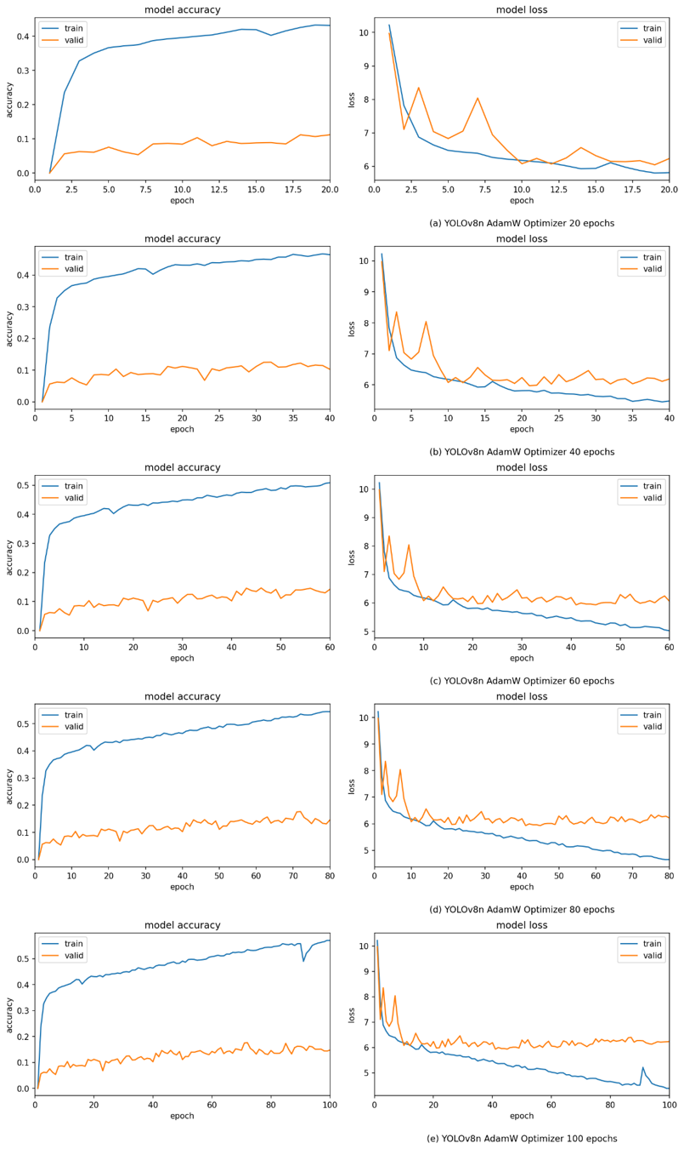(a) YOLOv8n AdamW Optimizer 20 epochs
(b)YOLOv8n AdamW Optimizer 40 epochs

(c)YOLOv8n AdamW Optimizer 60 epochs

(d) YOLOv8n AdamW Optimizer 80 epochs
(e)YOLOv8n AdamW Optimizer 100 epochs
Figure 12. YOLOv8n AdamW Optimizer Model Accuracy and Loss

Epochs | Accuracy (mAP@0.5) | Recall | Precision | F1
20 | 10.64% | 14.90 | 40.82 | 21.84
40 | 12.89% | 14.27 | 71.50 | 23.79
60 | 13.70% | 18.94 | 41.96 | 26.10
80 | 8.37% | 11.66 | 12.04 | 11.85
100 | 12.31% | 16.47 | 43.28 | 23.86
Average | 11.58% | 15.25 | 41.92 | 21.48
Table 14. YOLOv8n Results Using AdamW Optimizer
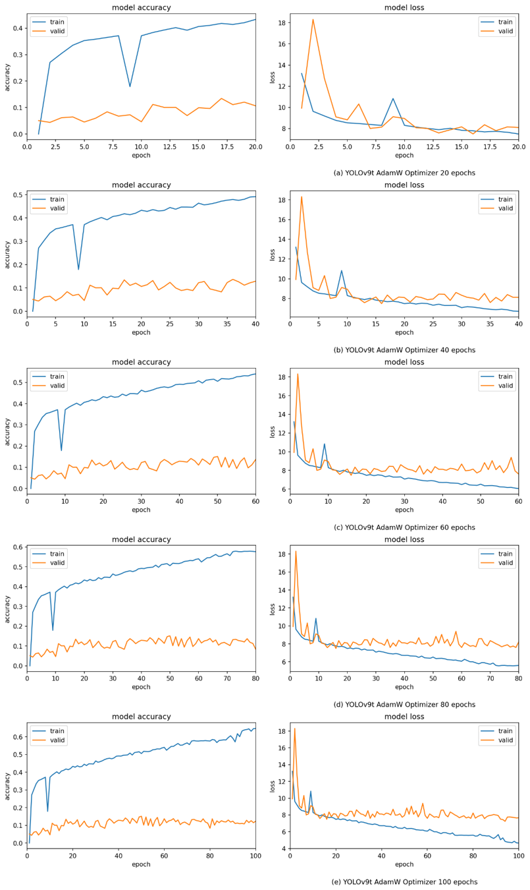
- YOLOv9t AdamW Optimizer 20 epochs

(b)YOLOv9t AdamW Optimizer 40 epochs

(c)YOLOv9t AdamW Optimizer 60 epochs

(d)YOLOv9t AdamW Optimizer 80 epochs

(e)YOLOv9t AdamW Optimizer 100 epochs
Figure 13. YOLOv9t AdamW Optimizer Model Accuracy and Loss
Epochs | Accuracy (mAP@0.5) | Recall | Precision | F1
20 | 13.71% | 15.65 | 68.46 | 25.48
40 | 9.65% | 13.20 | 64.75 | 21.93
60 | 10.91% | 14.90 | 17.61 | 16.14
80 | 10.06% | 14.00 | 43.72 | 21.21
100 | 11.43% | 14.55 | 70.49 | 24.12
Average | 11.15% | 14.46 | 53.00 | 21.77
Table 14. YOLOv8n Results Using AdamW Optimizer

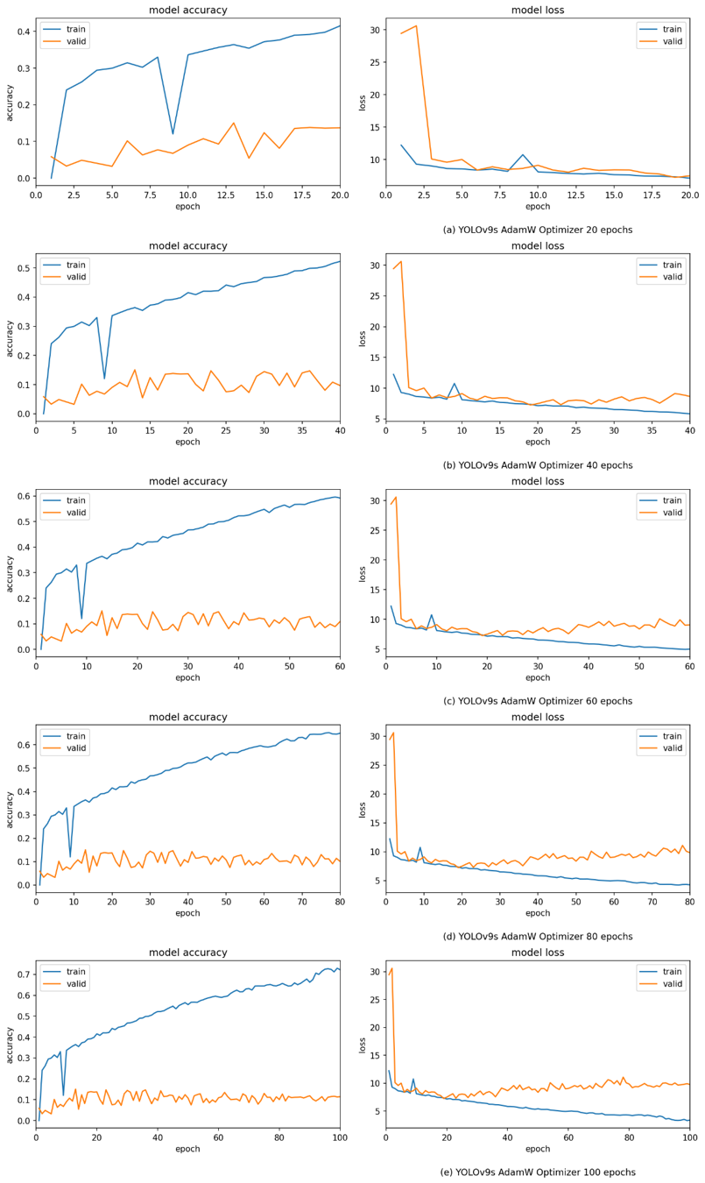(a)YOLOv9s AdamW Optimizer 20 epochs

(b)YOLOv9s AdamW Optimizer 40 epochs
(c) YOLOv9s AdamW Optimizer 60 epochs

(d) YOLOv9s AdamW Optimizer 80 epochs
(e)YOLOv9s AdamW Optimizer 100 epochs

Figure 13. YOLOv9s AdamW Optimizer Model Accuracy and Loss
Figure 13 shows the accuracy and loss curves of YOLOv8n trained with AdamW. The model was trained and evaluated at 20, 40, 60, and 80 epochs to observe how longer training affected learning behavior. The corresponding summary metrics at each interval are presented in Table 13.

System Maintenance
System maintenance keeps AGRIVISION usable after deployment. The plan covers defect correction, security upkeep, and later adjustments that remain within the original monitoring purpose.

Maintenance Plan
The proponents will apply a structured maintenance plan to examine and resolve bugs found during testing and to keep the user experience stable in operation. AGRIVISION is distributed as an executable file so that installation and updates do not require users to work in a development environment or with source code.

References
[1] A. E. Pérez-Matos, X. Cruz-González, R. I. Berríos-Villarini, T. Ortiz-Resto, G. Chompré-González, and N. Arroyo-González, "Fusarium oxysporum f.sp. cubense Tropical Race 4 (Foc TR4): Latent risk for banana and plantains crops in Puerto Rico," Curr. Agric. Res. J., vol. 11, no. 3, pp. 761-780, 2023, doi: 10.12944/CARJ.11.3.07.
[2] J. J. Mora, G. Blomme, N. Safari, S. Elayabalan, R. Selvarajan, and M. G. Selvaraj, "Digital framework for georeferenced multiplatform surveillance of banana wilt using human-in-the-loop AI and YOLO foundation models," Sci. Rep., vol. 15, p. 3491, 2025, doi: 10.1038/s41598-025-87588-2.
[3] R. Goenaga, B. Irish, and A. Marrero, "Yield and fruit quality traits of two banana cultivars grown at two locations in Puerto Rico under black leaf streak disease pressure," HortTechnology, 2021, doi: 10.21273/HORTTECH04914-21.
[4] R. D. Noar, E. Thomas, and M. E. Daub, "Genetic characteristics and metabolic interactions between Pseudocercospora fijiensis and banana: Progress toward controlling Black Sigatoka," Plants, vol. 11, no. 7, p. 948, Mar. 2022, doi: 10.3390/plants11070948.
[5] N. A. N. A. Yani, S. S. M. Fauzi, N. A. M. Zaki, and M. H. Ismail, "A systematic literature review on leaf disease recognition using computer vision and deep learning approach," J. Inf. Syst. Eng. Bus. Intell., vol. 10, no. 2, pp. 232-249, Jun. 2024, doi: 10.20473/jisebi.10.2.232-249.
[6] V. G. Krishnan, J. Deepa, P. V. Rao, V. Divya, and S. Kaviarasan, "An automated segmentation and classification model for banana leaf disease detection," J. Appl. Biol. Biotechnol., vol. 10, no. 1, pp. 213-220, Jan. 2022, doi: 10.7324/JABB.2021.100126.
[7] N. P. Vidhya and R. Priya, "Advanced deep learning approaches for image-based diagnosis of banana leaf diseases," AI Comput. Sci. Robot. Technol., vol. 5, pp. 1-16, 2026, doi: 10.5772/acrt.20250204.
[8] R. Alanazi, "A YOLOv10-based approach for banana leaf disease detection," Eng. Technol. Appl. Sci. Res., vol. 15, no. 3, pp. 23522-23526, 2025, doi: 10.48084/etasr.11138.
[9] B. Oviedo, C. Zambrano-Vega, R. O. Villamar-Torres, D. Yánez-Cajo, and K. Cedeño Campoverde, "Improved YOLOv8 segmentation model for the detection of Moko and Black Sigatoka diseases in banana crops with UAV imagery," Technologies, vol. 13, no. 9, p. 382, 2025, doi: 10.3390/technologies13090382.
[10] I. Teixeira, R. Morais, J. J. Sousa, and A. Cunha, "Deep learning models for the classification of crops in aerial imagery: A review," Agriculture, vol. 13, no. 5, p. 965, 2023, doi: 10.3390/agriculture13050965.
[11] M. D. Gerance, K. Sta. Rufina, J. Fabito, and N. Magnaye, "SaBaTech: A banana fruit pest and disease detection web application," Amer. J. Data Sci. Artif. Intell., vol. 1, no. 1, pp. 14-20, 2025, doi: 10.54536/ajdsai.v1i1.4890.
[12] S. Nasim, M. Rashid, S. A. Syed, and I. Brohi, "Artificial intelligence techniques for the pest detection in banana field: A systematic review," Pak. J. Biotechnol., vol. 20, no. 2, pp. 209-223, 2023, doi: 10.34016/pjbt.2023.20.02.746.
[13] J. B. Ancheta et al., "Development of a classification model for banana leaf disease using Google Teachable Machine," in Proc. Int. Conf. Artif. Intell. Inf. Commun. (ICAIIC), 2025, pp. 258-263, doi: 10.1109/ICAIIC62882.2025.10978658.
[14] L. G. A. Erasmo and R. M. L. Perito, "AI-based banana disease classification using CNN MobileNetV2 model," SSRN, 2023, doi: 10.2139/ssrn.4891589.
[15] S. Nassor, M. Mushthofa, and K. Priandana, "Deep learning model for detection and classification of banana diseases based on leaf images," IOP Conf. Ser. Earth Environ. Sci., vol. 1359, p. 012010, 2024, doi: 10.1088/1755-1315/1359/1/012010.
[16] A. Ahmad, V. Aggarwal, D. Saraswat, A. El Gamal, and G. S. Johal, "GeoDLS: A deep learning-based corn disease tracking and location system using RTK geolocated UAS imagery," Remote Sens., vol. 14, no. 17, p. 4140, Aug. 2022, doi: 10.3390/rs14174140.
[17] J. J. Mora, M. G. Selvaraj, C. I. Alvarez, N. Safari, and G. Blomme, "From pixels to plant health: Accurate detection of banana Xanthomonas wilt in complex African landscapes using high-resolution UAV images and deep learning," Discover Appl. Sci., vol. 6, p. 377, 2024, doi: 10.1007/s42452-024-06073-z.
[18] C. A. Elinisa, C. W. Maina, A. Vodacek, and N. Mduma, "Image segmentation deep learning model for early detection of banana diseases," Appl. Artif. Intell., vol. 39, no. 1, e2440837, 2025, doi: 10.1080/08839514.2024.2440837.
[19] J. Kimunye et al., "Genotype x environment response of Matooke hybrids (NARITAs) to Pseudocercospora fijiensis, the cause of Black Sigatoka in banana," Agronomy, vol. 11, no. 6, p. 1145, Jun. 2021, doi: 10.3390/agronomy11061145.
[20] M. Francisco, F. Ribeiro, J. Metrôlho, and R. Dionísio, "Algorithms and models for automatic detection and classification of diseases and pests in agricultural crops: A systematic review," Appl. Sci., vol. 13, no. 8, p. 4720, Apr. 2023, doi: 10.3390/app13084720.
[21] D.-C. Rodríguez-Lira et al., "Trends in machine and deep learning techniques for plant disease identification: A systematic review," Agriculture, vol. 14, no. 12, p. 2188, 2024, doi: 10.3390/agriculture14122188.
[22] I. Pacal et al., "A systematic review of deep learning techniques for plant diseases," Artif. Intell. Rev., vol. 57, p. 304, 2024, doi: 10.1007/s10462-024-10944-7.
[23] S. Kamalesh Kanna, R. Kumaraperumal, P. Pazhanivelan, R. Jagadeeswaran, and P. C. Prabu, "YOLO deep learning algorithm for object detection in agriculture: A review," J. Agric. Eng., vol. 55, p. 1641, 2024, doi: 10.4081/jae.2024.1641.
[24] Z. Khan, Y. Shen, and H. Liu, "Object detection in agriculture: A comprehensive review of methods, applications, challenges, and future directions," Agriculture, vol. 15, no. 13, p. 1351, 2025, doi: 10.3390/agriculture15131351.
[25] F. Masykur, K. Adi, and O. D. Nurhayati, "Approach and analysis of YOLOv4 algorithm for rice diseases detection at different drone image acquisition distances," TEM J., vol. 12, no. 2, pp. 928-935, May 2023, doi: 10.18421/TEM122-39.
[26] P. Pan, W. Guo, X. Zheng, L. Hu, G. Zhou, and J. Zhang, "Xoo-YOLO: A detection method for wild rice bacterial blight in the field from the perspective of unmanned aerial vehicles," Front. Plant Sci., vol. 14, 1256545, 2023, doi: 10.3389/fpls.2023.1256545.

